Name: | Han Chen
NetID: | Hanc7
Section: | Zj1

ECE 408/CS483 Milestone 3 Report
- List Op Times, whole program execution time, and accuracy for batch size of 100, 1k, and 5k images from your basic forward convolution kernel in milestone 2. This will act as your baseline this milestone. Note: Do not use batch size of 10k when you profile in --queue rai_amd64_exclusive. We have limited resources, so any tasks longer than 3 minutes will be killed. Your baseline M2 implementation should comfortably finish in 3 minutes with a batch size of 5k (About 1m35 seconds, with nv-nsight).
Batch Size | Op Time 1 | Op Time 2 | Total Execution Time | Accuracy
100 | 0.318185 ms | 2.08727 ms | 0m0.193s | 0.86
1000 | 3.04541 ms | 20.5922 ms | 0m0.385s | 0.886
5000 | 15.6676 ms | 101.485 ms | 0m1.084s | 0.871

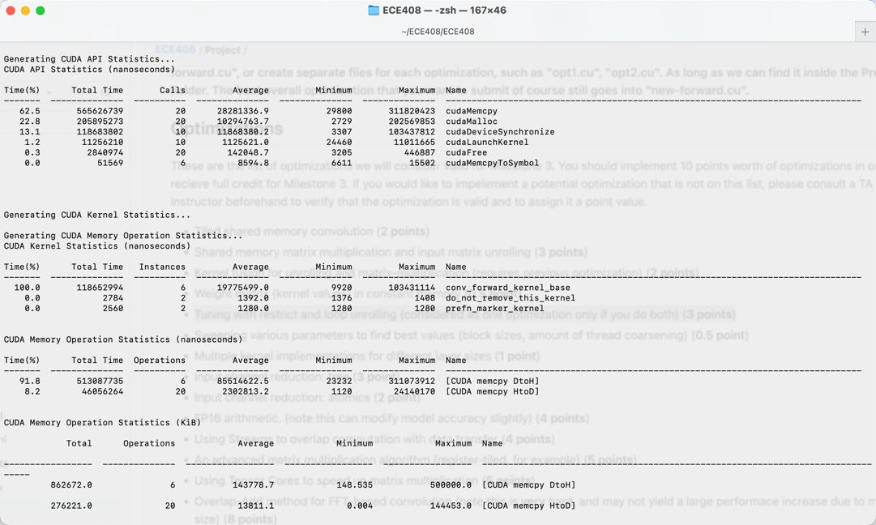

- Optimization 1: Weight matrix (kernel values) in constant memory (0.5 point)
  - Which optimization did you choose to implement and why did you choose that optimization technique.
Weight matrix (kernel values) in constant memory, because this can save the times that we retrieve value from global memory.
  - How does the optimization work? Did you think the optimization would increase performance of the forward convolution? Why? Does the optimization synergize with any of your previous optimizations?
This optimization replaces reading from global memory to constant memory. Yes, this is because it reduces the times that you use to retrieve value from global memory. This is the first optimization, but I am sure that it can synergize with any other optimization as other optimization will not change the usage of mask array.
  - List the Op Times, whole program execution time, and accuracy for batch size of 100, 1k, and 5k images using this optimization (including any previous optimizations also used).
Batch Size | Op Time 1 | Op Time 2 | Total Execution Time | Accuracy
100 | 0.281437 ms | 1.86507 ms | 0m0.225s | 0.86
1000 | 2.67664 ms | 18.412 ms | 0m0.396s | 0.886
5000 | 13.3038 ms | 92.1523 ms | 0m0.916s | 0.871

  - Was implementing this optimization successful in improving performance? Why or why not? Include profiling results from nsys and Nsight-Compute to justify your answer, directly comparing to your baseline (or the previous optimization this one is built off of).
Yes, because it reduces the times that you use to retrieve value from global memory.
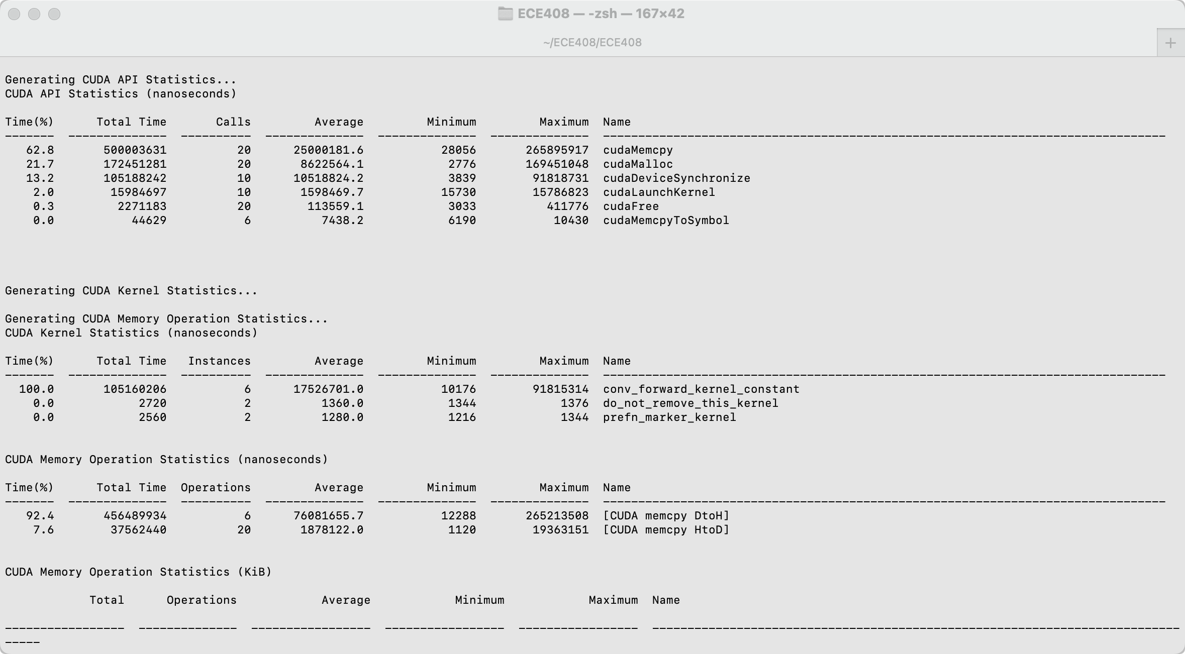
We can tell that the total time of all parts decrease.
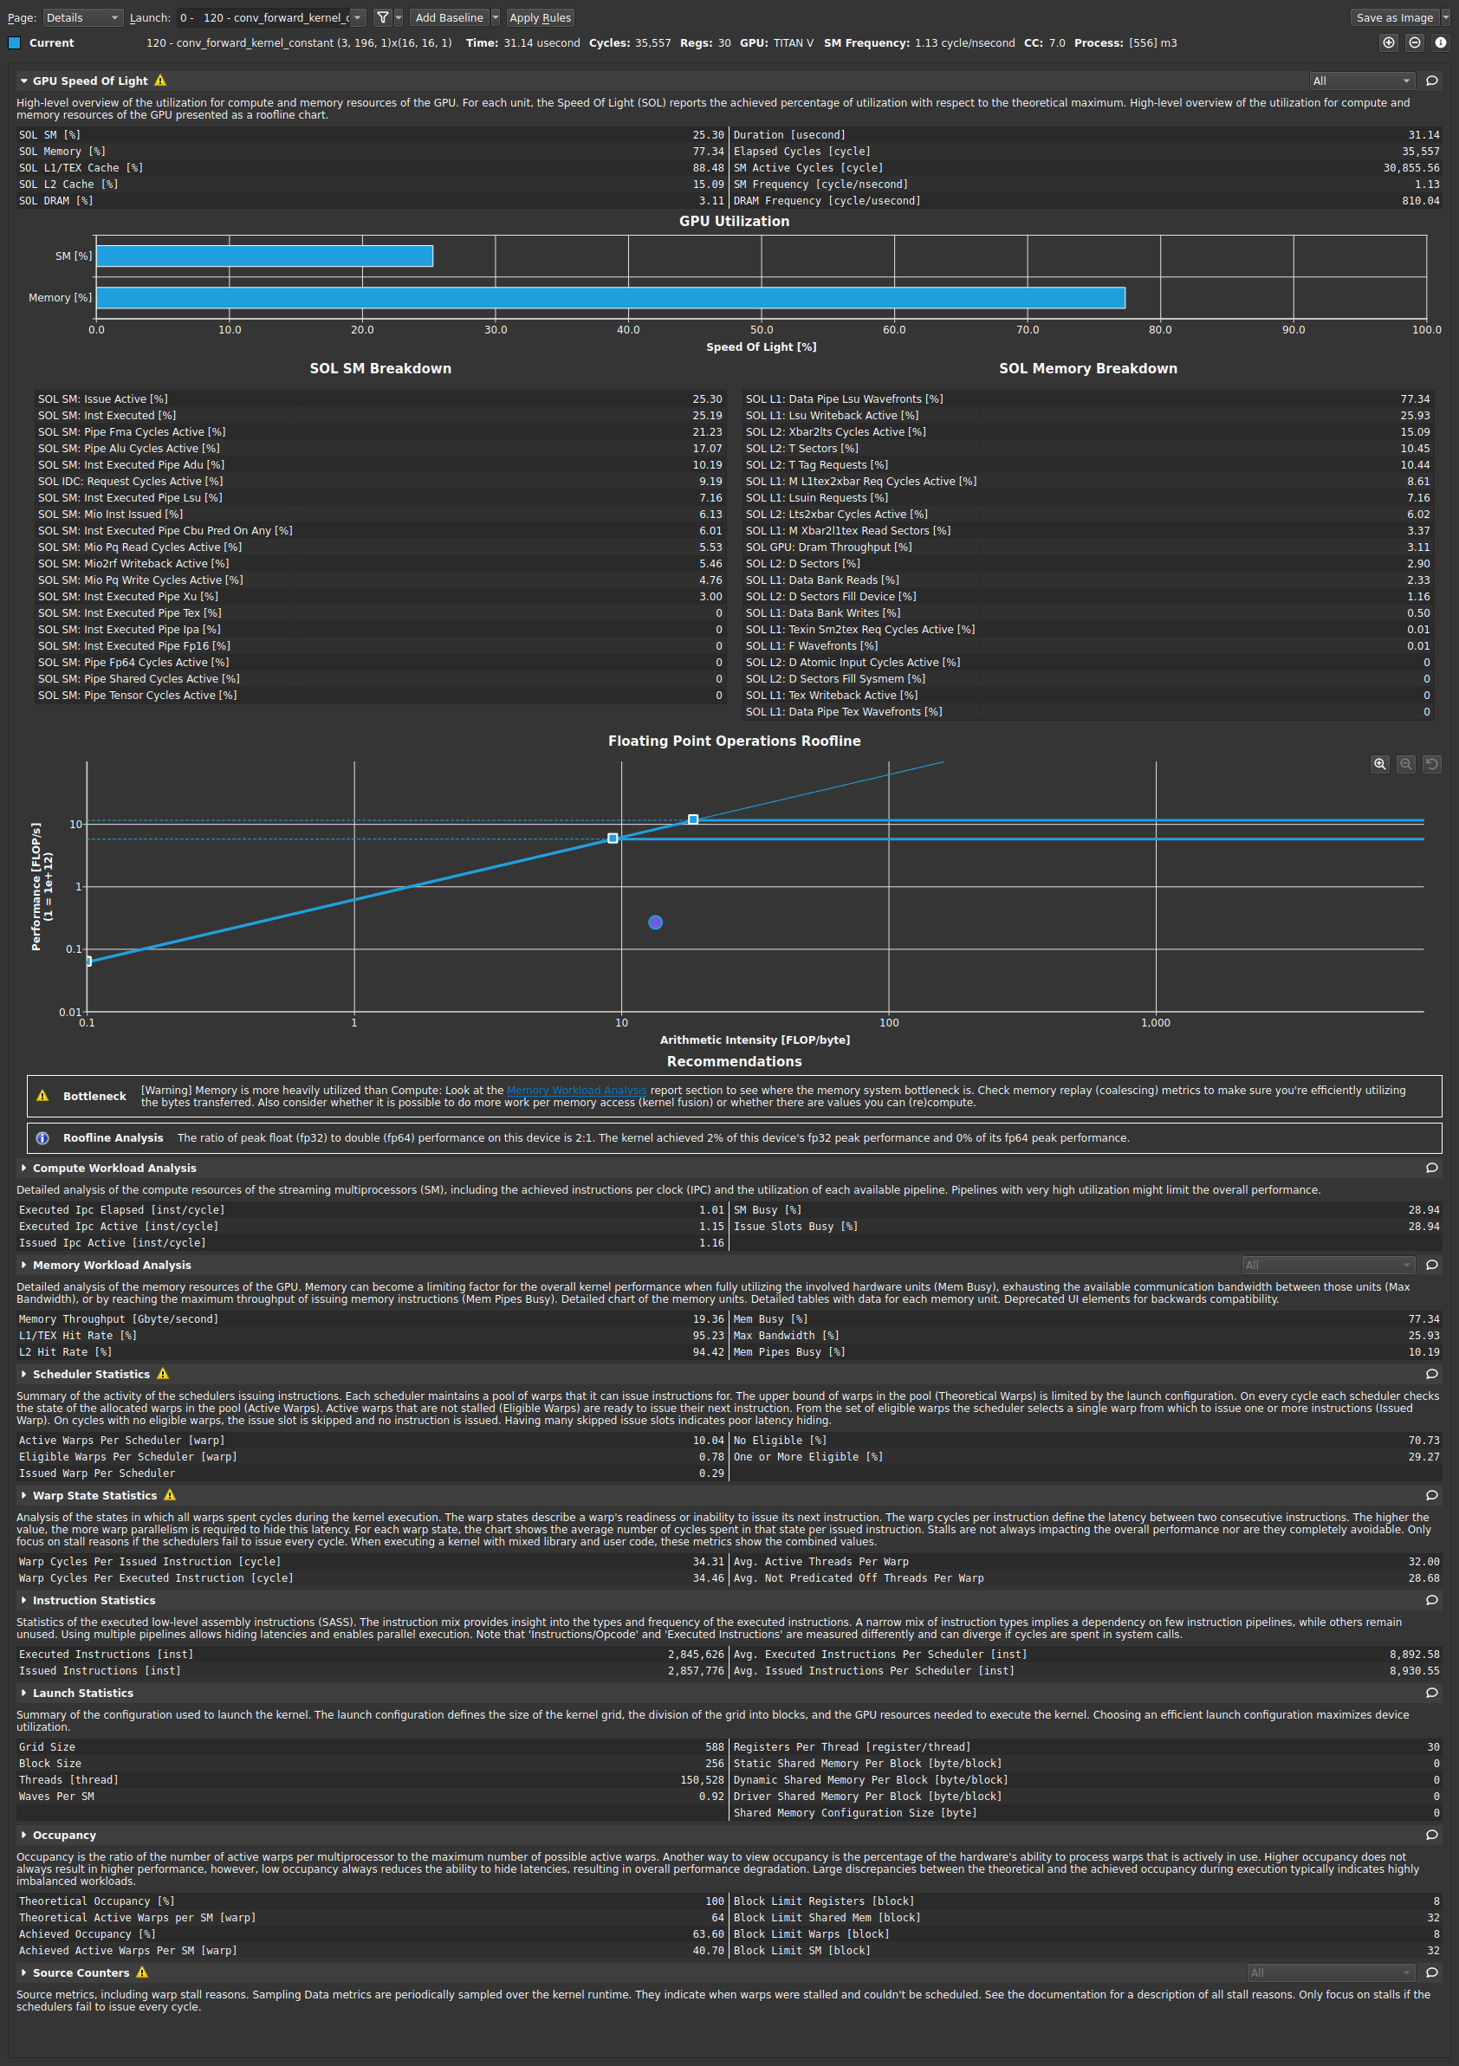
  - What references did you use when implementing this technique?
“constant memory” from lecture 7.
- Optimization 2: Tiled shared memory convolution (2 points)
- Which optimization did you choose to implement and why did you choose that optimization technique.
Tiled shared memory convolution. I think this can reduce the number of times that I retrieve input values from global memory so that the performance will be better.
- How does the optimization work? Did you think the optimization would increase performance of the forward convolution? Why? Does the optimization synergize with any of your previous optimizations?
We will read a portion of input value and store into shared memory to reduce the times that I read from global memory so that we spend less time. Yes, this will synergize with previous optimization of storing the mask into constant memory.
- List the Op Times, whole program execution time, and accuracy for batch size of 100, 1k, and 5k images using this optimization (including any previous optimizations also used).
Batch Size | Op Time 1 | Op Time 2 | Total Execution Time | Accuracy
100 | 0.376543 ms | 1.47727 ms | 0m0.213s | 0.86
1000 | 3.57791 ms | 14.5086 ms | 0m0.280s | 0.886
5000 | 17.7052 ms | 72.5626 ms | 0m0.960s | 0.871

- Was implementing this optimization successful in improving performance? Why or why not? Include profiling results from nsys and Nsight-Compute to justify your answer, directly comparing to your baseline (or the previous optimization this one is built off of).
Yes, it is successful. We will read a portion of input value and store into shared memory to reduce the times that I read from global memory so that we spend less time.
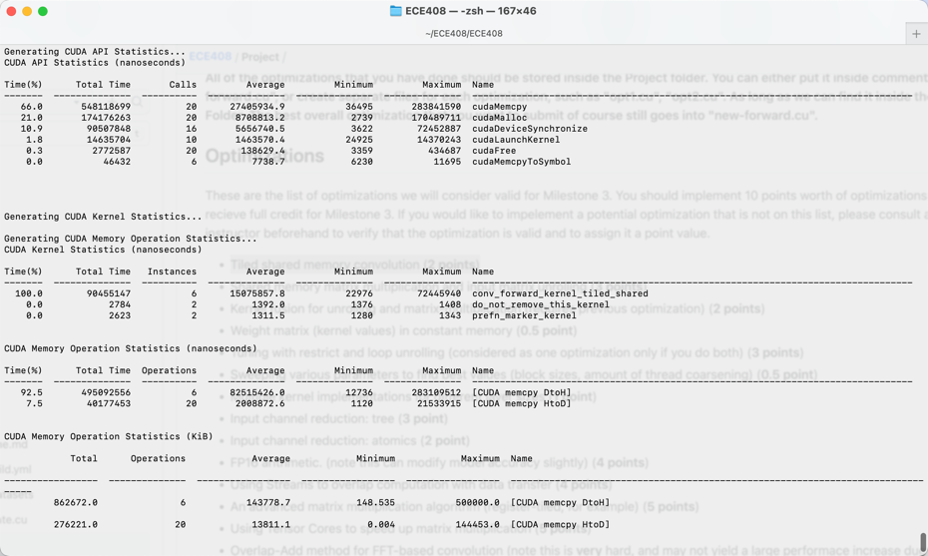
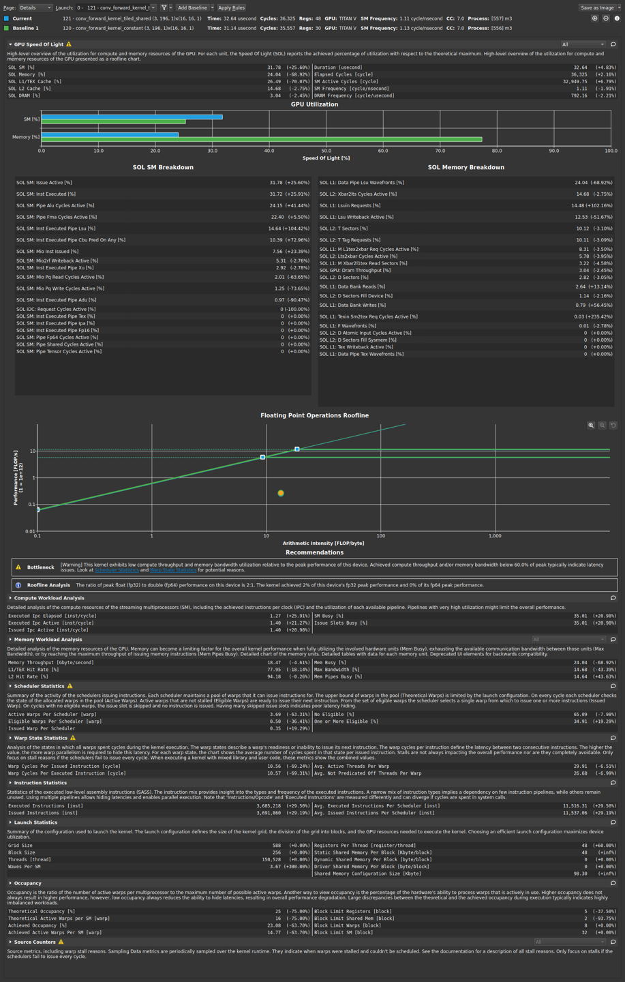
- What references did you use when implementing this technique?
The tiled convolution technique in lecture 8.
- Optimization 3: Tuning with restrict and loop unrolling (considered as one optimization only if you do both) (3 points)
  - Which optimization did you choose to implement and why did you choose that optimization technique.
Tuning with restrict and loop unrolling (considered as one optimization only if you do both). I choose this because it is easy to implement and has remarkable upgrade.
  - How does the optimization work? Did you think the optimization would increase performance of the forward convolution? Why? Does the optimization synergize with any of your previous optimizations?
This optimization unrolls the calculation by loop, avoids using loop to calculate and directly adds up the sum of all three channels, so that we reduce the time in updating iterative number such as i. Yes it will increase the performance. And this optimization synergizes with all previous optimizations. Also, The __restrict__ keyword allows the compiler to make certain assumptions about the absence of pointer aliasing, which can lead to more aggressive optimizations.
  - List the Op Times, whole program execution time, and accuracy for batch size of 100, 1k, and 5k images using this optimization (including any previous optimizations also used).
Batch Size | Op Time 1 | Op Time 2 | Total Execution Time | Accuracy
100 | 0.328119 ms | 2.08456 ms | 0m0.211s | 0.86
1000 | 3.03235 ms | 20.3188 ms | 0m0.328s | 0.886
5000 | 14.9039 ms | 91.0078 ms | 0m0.972s | 0.871

  - Was implementing this optimization successful in improving performance? Why or why not? Include profiling results from nsys and Nsight-Compute to justify your answer, directly comparing to your baseline (or the previous optimization this one is built off of).
Yes. This optimization avoids using loop to calculate and directly adds up the sum of all three channels, so that we reduce the time in updating iterative number such as i. Yes it will increase the performance.
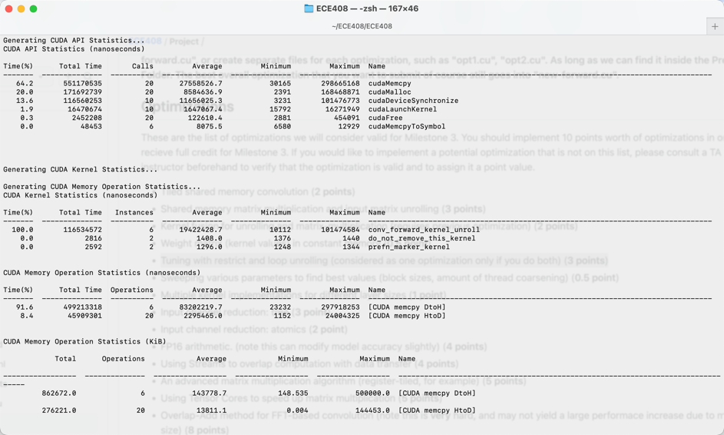
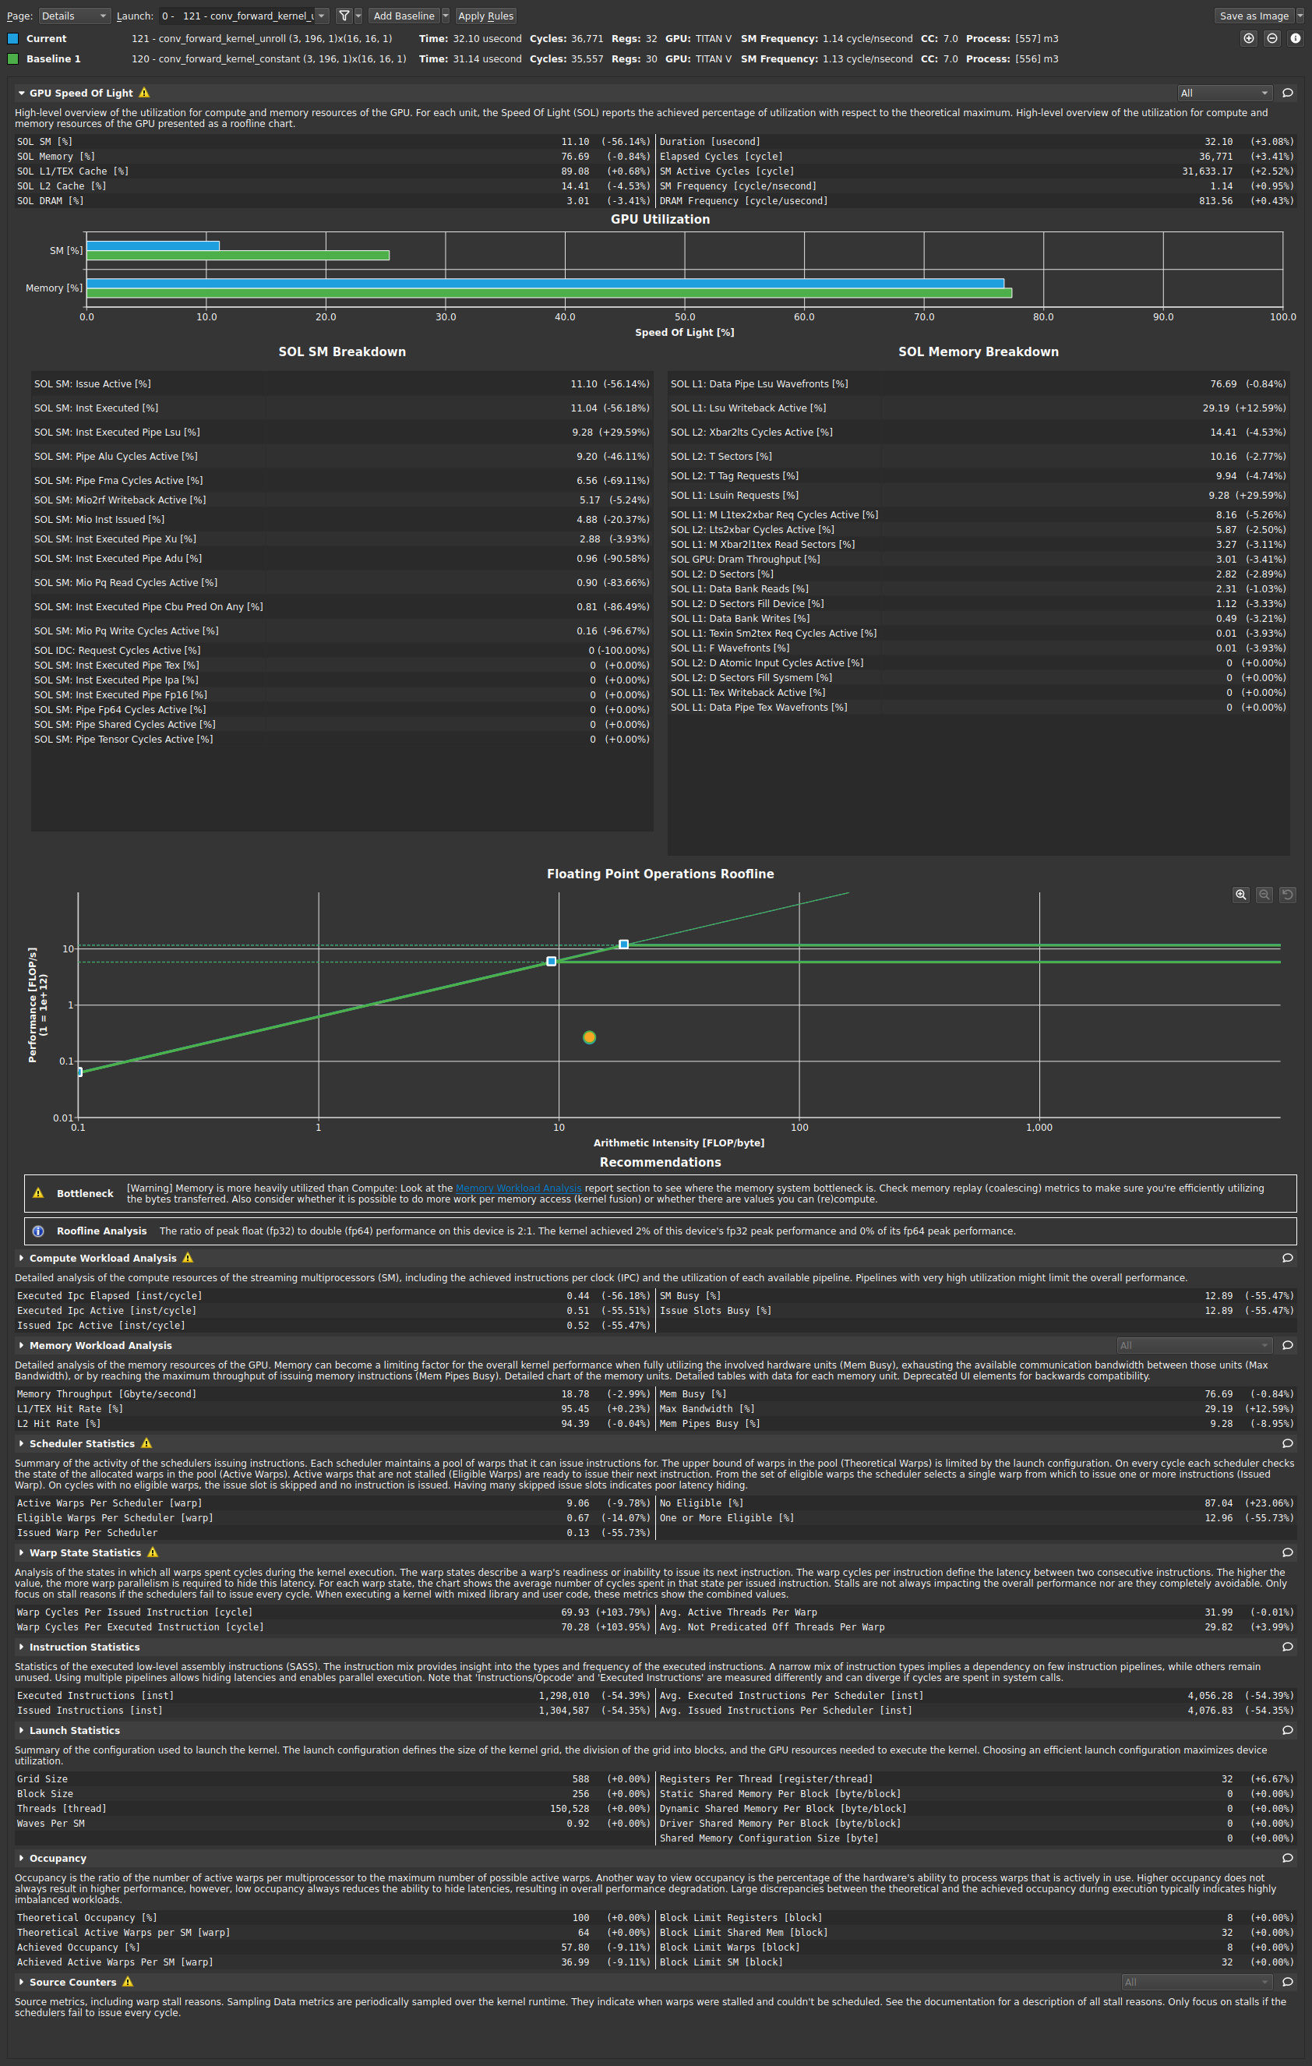
  - What references did you use when implementing this technique?
https://docs.nvidia.com/cuda/cuda-c-programming-guide/index.html#restrict
- Optimization 4: FP16 arithmetic. (note this can modify model accuracy slightly) (4 points)
  - Which optimization did you choose to implement and why did you choose that optimization technique.
FP16 arithmetic. (note this can modify model accuracy slightly). I choose this because Mixed precision training offers significant computational speedup by performing operations in half-precision format, while storing minimal information in single-precision to retain as much information as possible in critical parts of the network.
  - How does the optimization work? Did you think the optimization would increase performance of the forward convolution? Why? Does the optimization synergize with any of your previous optimizations?
I first use a kernel to cast device_in and mask into half type, then run base forward function (also change the type in function head to half type), and finally run another kernel to cast out from half type to float type.
I think it will increase the performance. And, The more float calculation, the better the performance is. This optimization can synergize will all previous optimization.
  - List the Op Times, whole program execution time, and accuracy for batch size of 100, 1k, and 5k images using this optimization (including any previous optimizations also used).
Batch Size | Op Time 1 | Op Time 2 | Total Execution Time | Accuracy
100 | 0.586076 ms | 1.51916 ms | 0m0.224s | 0.86
1000 | 4.13122 ms | 12.9303 ms | 0m0.284s | 0.887
5000 | 19.283 ms | 63.3033 ms | 0m0.764s | 0.8712

  - Was implementing this optimization successful in improving performance? Why or why not? Include profiling results from nsys and Nsight-Compute to justify your answer, directly comparing to your baseline (or the previous optimization this one is built off of).
Yes. This is because mixed precision training offers significant computational speedup by performing operations in half-precision format, while storing minimal information in single-precision to retain as much information as possible in critical parts of the network. Especially for large batch size, the optimization is better as there are more float computation that are switched to half computation.
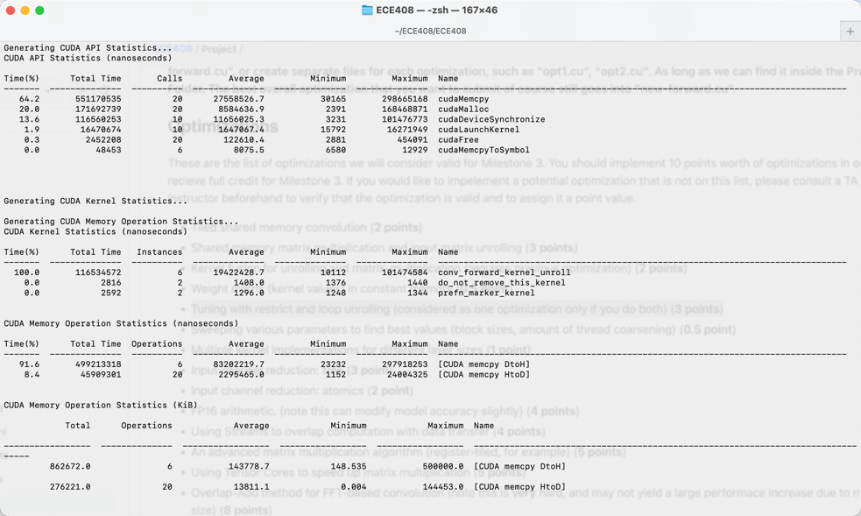
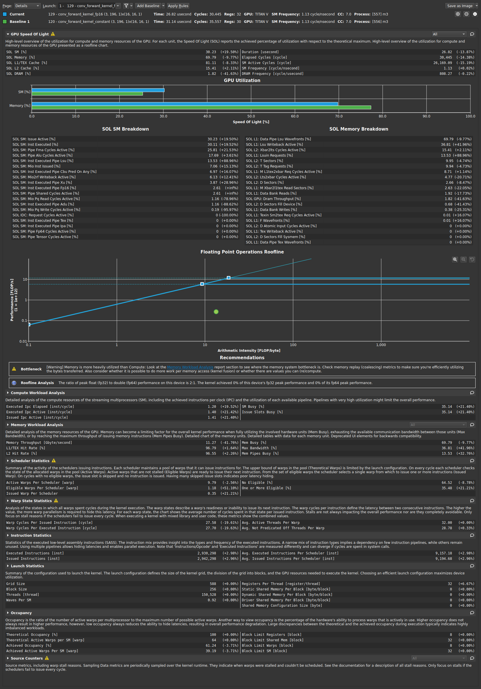
  - What references did you use when implementing this technique?
https://docs.nvidia.com/deeplearning/performance/mixed-precision-training/index.html
- Optimization 5: Sweeping various parameters to find best values (block sizes, amount of thread coarsening) (0.5 point)
  - Which optimization did you choose to implement and why did you choose that optimization technique.
Sweeping various parameters to find best values (block sizes, amount of thread coarsening). I choose this because the coarsening and block size will affect the performance greatly.
  - How does the optimization work? Did you think the optimization would increase performance of the forward convolution? Why? Does the optimization synergize with any of your previous optimizations?
I change different block size and record the final op time and compare the performance. I think maybe larger block size will have better performance in shared tile scenario as it stores more value and reduces more times of reading from global memory. And this optimization synergize with all previous optimizations. My record below is tested in tile_shared method with different block size.
  - List the Op Times, whole program execution time, and accuracy for batch size of 100, 1k, and 5k images using this optimization (including any previous optimizations also used).
Blocksize 16:
Batch Size | Op Time 1 | Op Time 2 | Total Execution Time | Accuracy
100 | 0.376543 ms | 1.47727 ms | 0m0.213s | 0.86
1000 | 3.57791 ms | 14.5086 ms | 0m0.280s | 0.886
5000 | 17.7052 ms | 72.5626 ms | 0m0.960s | 0.871

Blocksize 12:
Batch Size | Op Time 1 | Op Time 2 | Total Execution Time | Accuracy
5000 | 30.3936 ms | 66.3541 ms | 0m0.853s | 0.871

Blocksize 8:
Batch Size | Op Time 1 | Op Time 2 | Total Execution Time | Accuracy
5000 | 56.8197 ms | 167.527 ms | 0m0.853s | 0.871

Blocksize 4:
Batch Size | Op Time 1 | Op Time 2 | Total Execution Time | Accuracy
5000 | 273.399 ms | 558.748 ms | 0m0.924s | 0.871

  - Was implementing this optimization successful in improving performance? Why or why not? Include profiling results from nsys and Nsight-Compute to justify your answer, directly comparing to your baseline (or the previous optimization this one is built off of).
Yes. We can tell from the op time that it is the fastest when block size is 16 from the time of conv_forward_kernel_tiled_shared below. In this case, larger block means reducing more times reading from global memory because of preparing larger shared memory ahead. The opt time in the diagram above shows 12 is a better choice. I think it may relates with reading from the memory, and Blocksize 12 may fits better for coarsening. Or it can also accounts for the fluctuation, since it also has worse performance when I try to test multiple times.
I only include the blocksize8, blocksize12 and blocksize16 nsys and nsight-compute here to justify my answer.

Blocksize16:
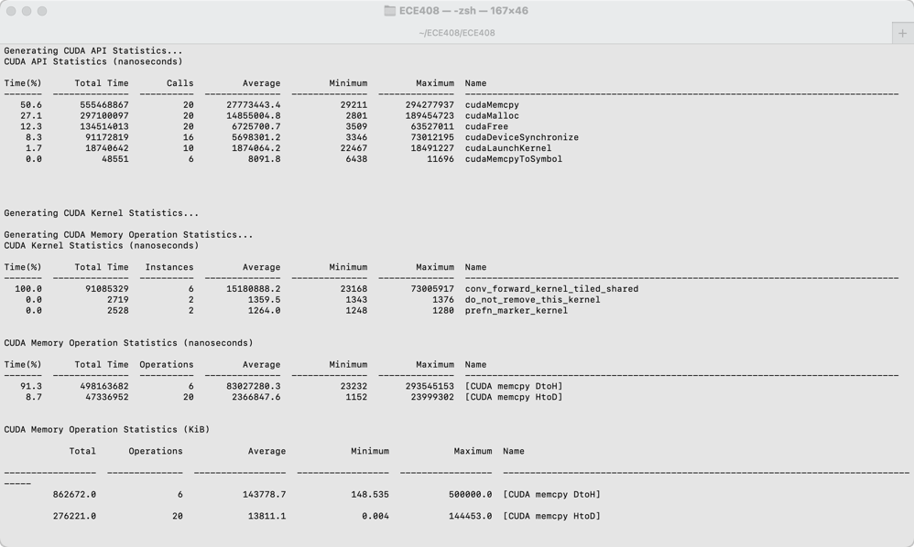
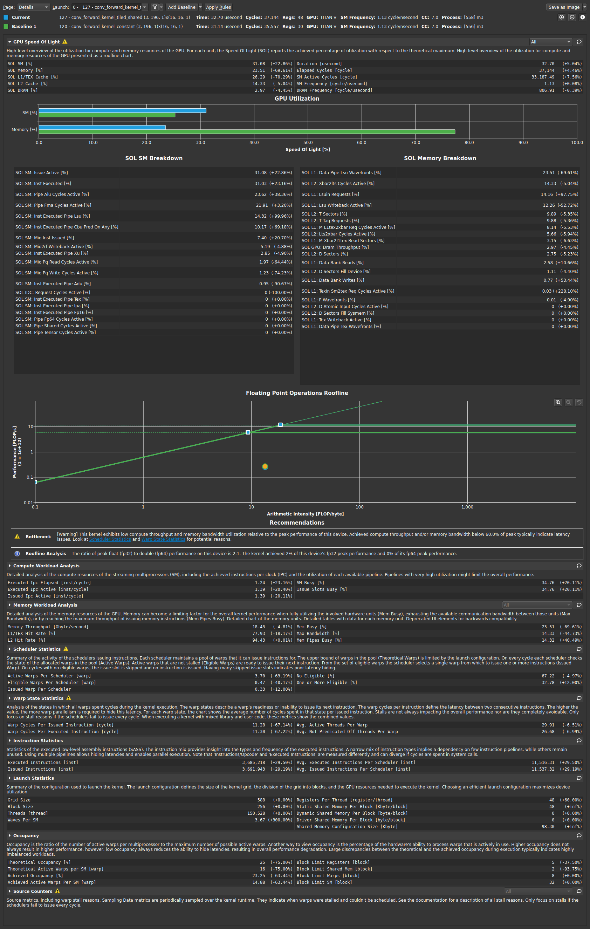
Blocksize12:
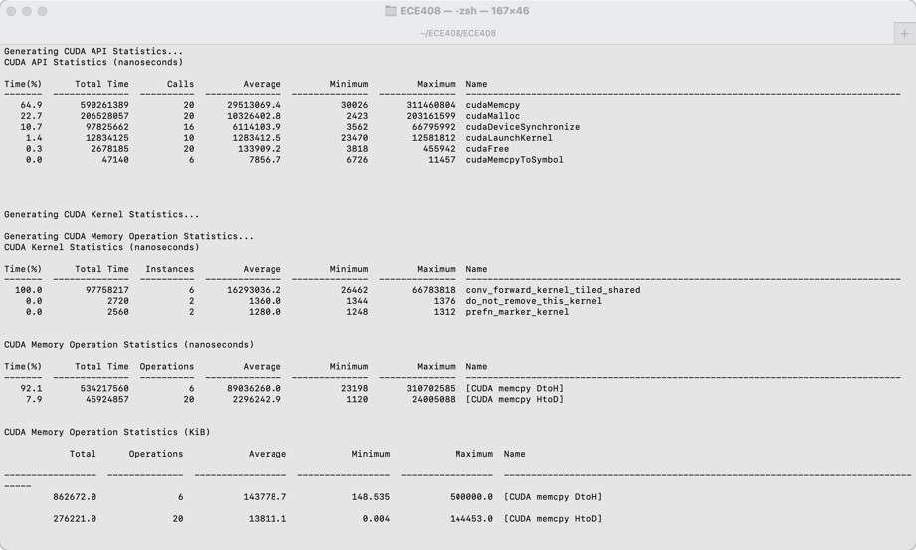
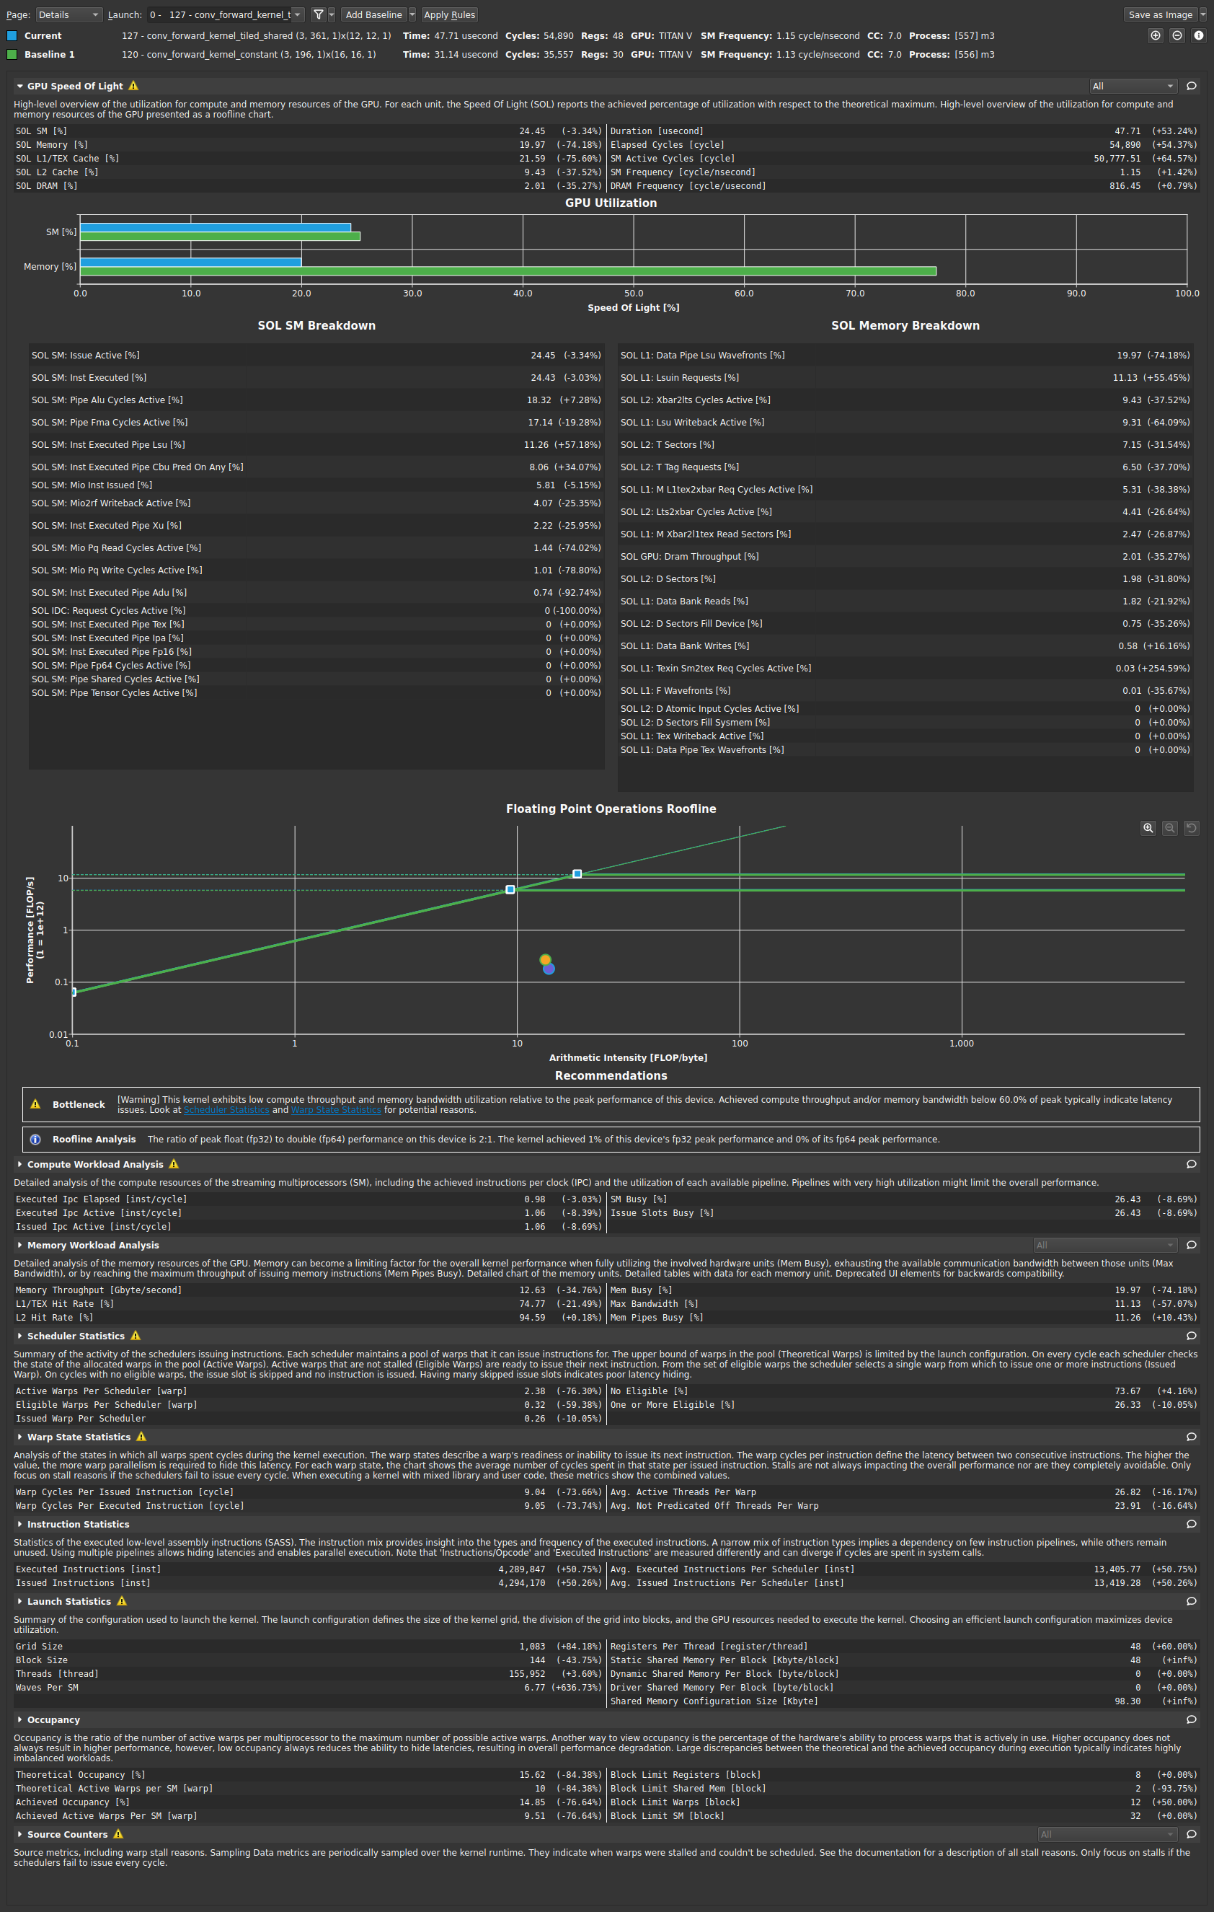
Blocksize8:
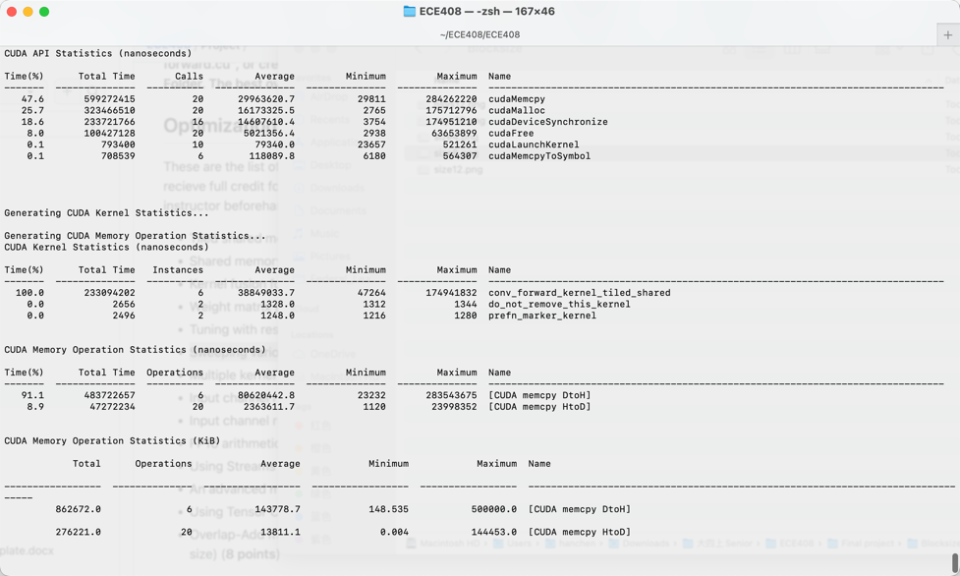
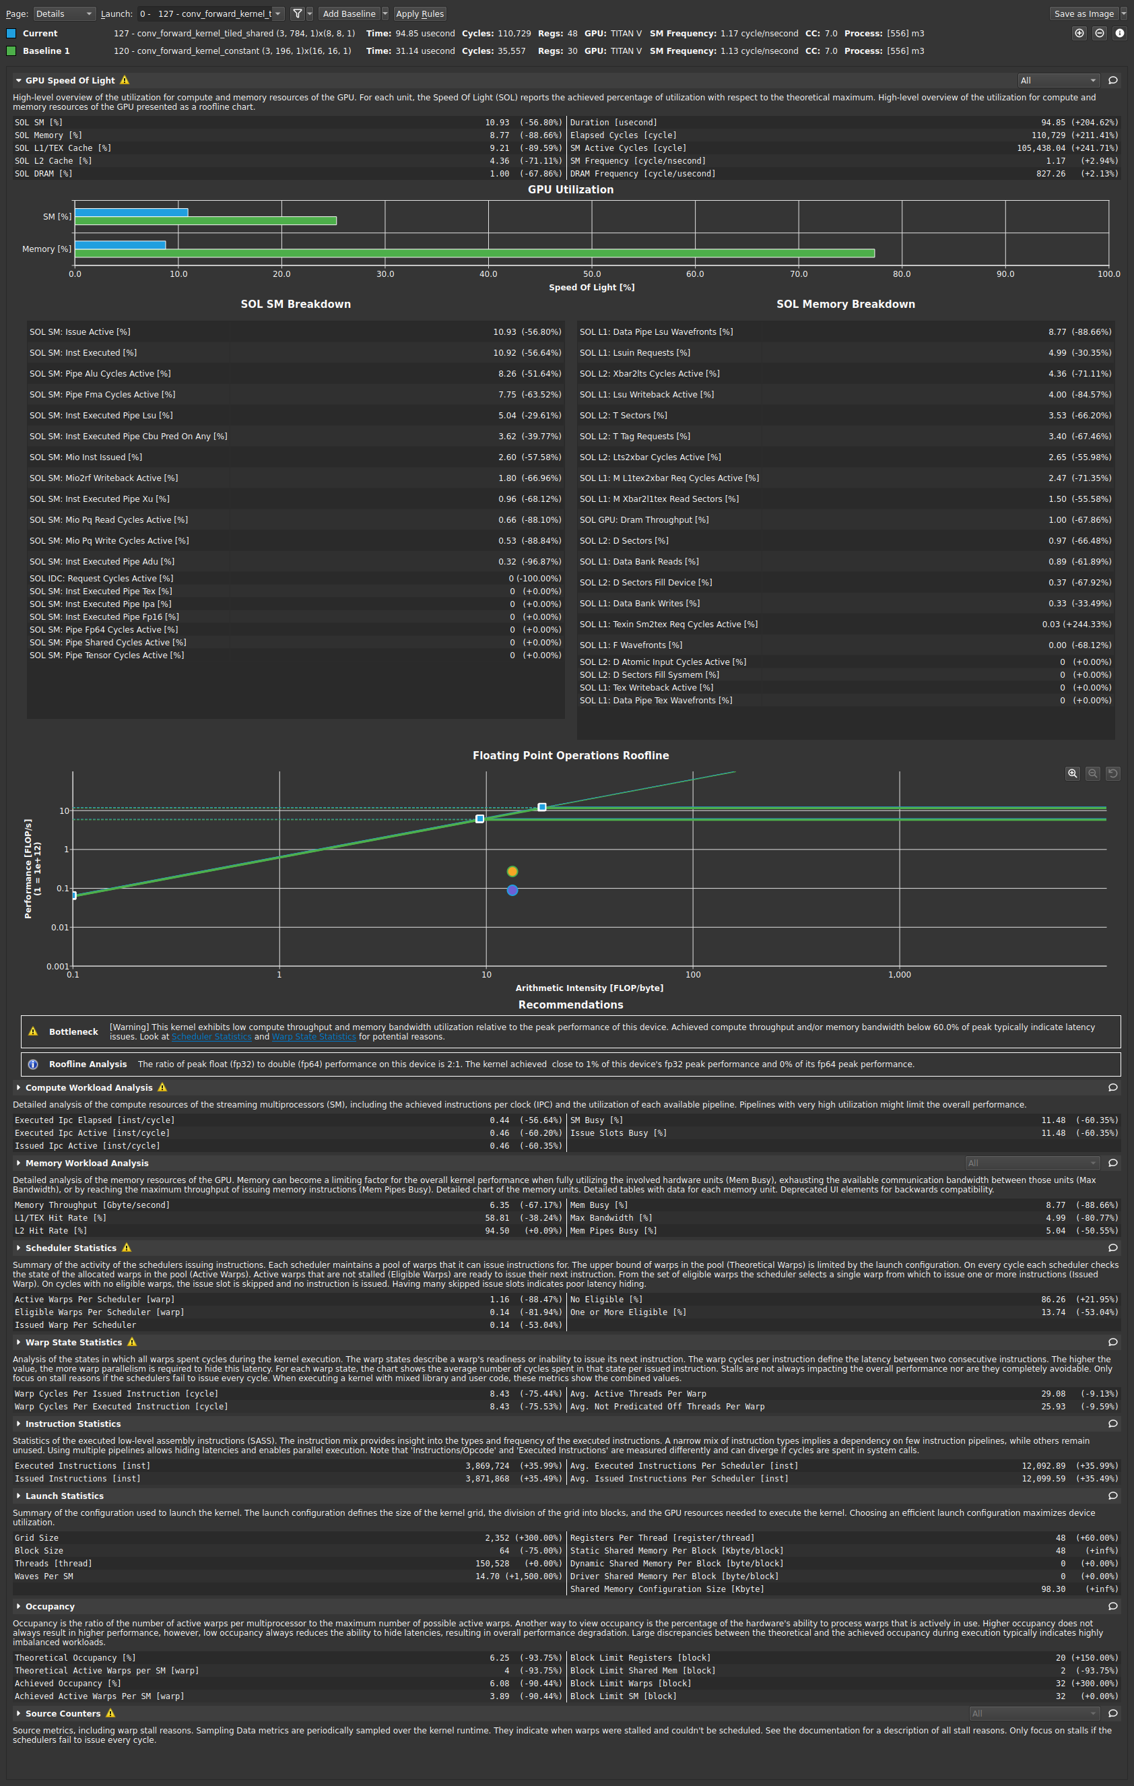
  - What references did you use when implementing this technique?
No reference
After adding all optimization into one part, I got the final result in 40ms.
